**Use of the** **“GeneralHeatmap” DSP DA script**

**Intended use**

The General Heatmap DSP DA script was designed for data from the GeoMx nCounter (protein or RNA) or GeoMx NGS (CTA/WTA) readout applications. It creates publication ready labeled heatmaps based on user inputs.

**Contents**

*Page 2*: Loading into the DSP DA

*Page 3:* Setting User Parameters

*Page 5*: Example Parameter Set-up

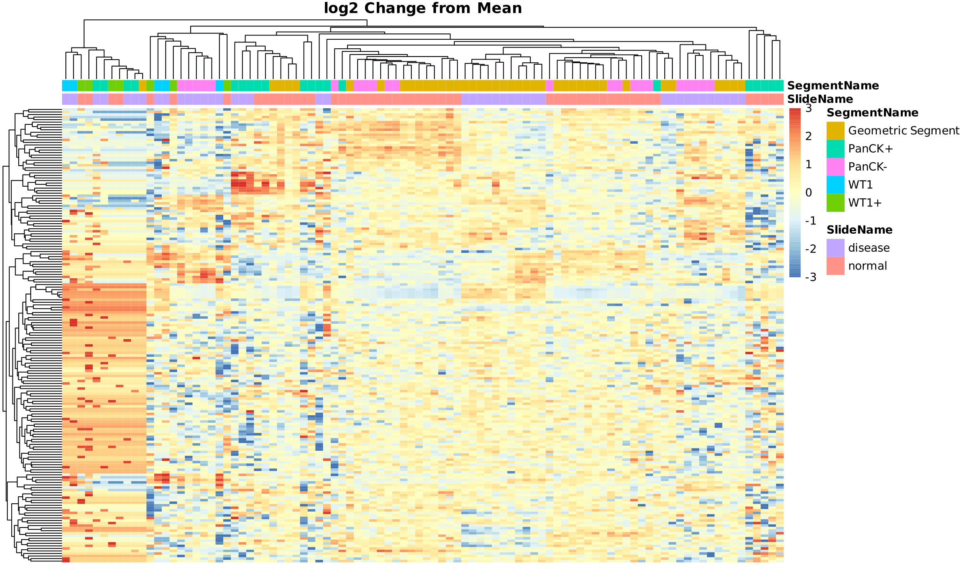

*For more example graphs see page 5*

**Loading into the DSP DA**

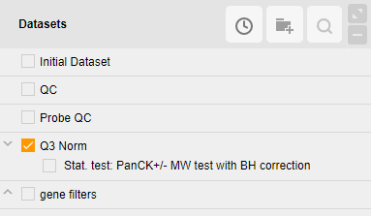The GeneralHeatmap.R file may be loaded into the custom scripts section of the DSP DA after you have a dataset processed and ready for analysis. Filtering of targets and segments must happen before using this custom script. To do so open the custom script section by clicking on the button shown below with the statistical test dataset unmarked:



Select the “Manage” tab to open the area to load and edit scripts:

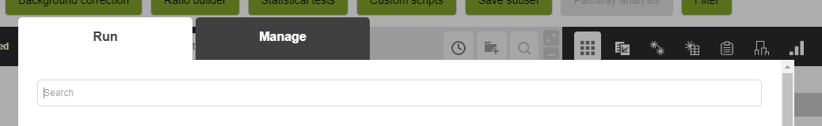

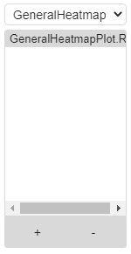In the Management tab to add a new script and adjust parameters, fill out and then scroll to the bottom of the page. Use the “+” button to add the GeneralHeatmap.R file to the script:

Once added the parameters of the script can be adjusted by editing the top lines in the script and hitting the “Save” button. You do **not** need to check the Create new dataset button.

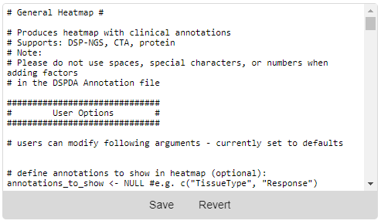

**Setting User Parameters:**

There are 15 settings that can be adjusted by the user at the top of the plug-in script. All parameters are optional. These include:

**Files**

1. *annotations_to_show:*(String) Segment annotations to show in heatmap, set to NULL if none needed
2. *custom_annotation_colors*: (Boolean) Should User defined colors be used? Otherwise pheatmap defaults will be used
   * *annotation_colors*: (List) Color for each unique factor in each segment shown

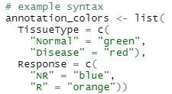

Options in Annotation

Annotation

1. *sort_by*: (String) If supervised clustering is wanted, which segment annotation should sorting be performed on. Set to NULL if unsupervised clustering is desired
2. *sort_order*: (String) If supervised clustering is wanted, what order should the annotations be ordered in. Set to NULL if unsupervised clustering is desired

**Advanced User Options**

1. *heatmap_colors:* (String) Color scheme for the heatmap, set to NULL if default is desired
   * example = c("navy", "white", "firebrick3")
2. *scale_cutoff:* (Numeric) Max (and absolute min) of heatmap color and legend scale
   * 
3. *show_sample_names*: (Boolean) Should sample names be shown on figure
4. *show_target_names*: (Boolean) Should target names be shown on figure
5. *clustering_distance:* (String)clustering distance for unsupervised clustering; default = Euclidean
   * options: "euclidean", "correlation" (Pearson's), "maximum", "manhattan", "canberra", "binary", or "minkowski"
6. *scale:* (String)axis to scale and center values on; default = row
   * options*:* “none”, “row”, “column”
7. *fontsize*: (Numeric)Font size for text in figure
8. *plot_title:* (String) Figure Title
9. *file_type:* (String) Desired output format for the figure
   * options: “pdf”, “svg”, “png”, “tiff”
10. *plot_width:* (Numeric) Width of saved figure in inches
11. *plot_height:* (Numeric) Height of saved figure in inches

**For color options:**

Colors that can be recognized by R should be either named colors (e.g. “orange2”) or hexadecimal colors (“#ABABAB”). See below for a cheat sheet of all named R colors.

**Named R Colors:**

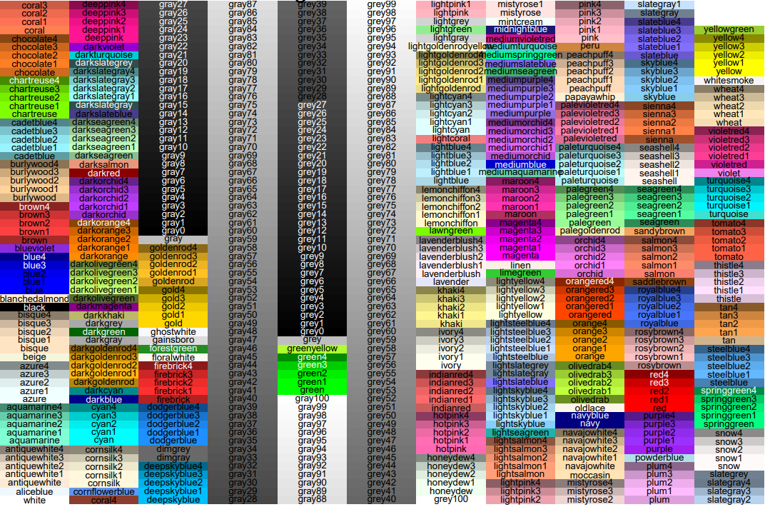

**Example Parameter Set-up**

The GeneralHeatmap script outputs a typical heatmap figure with log2 change from mean expression.

*Example figures with different input arguments.*

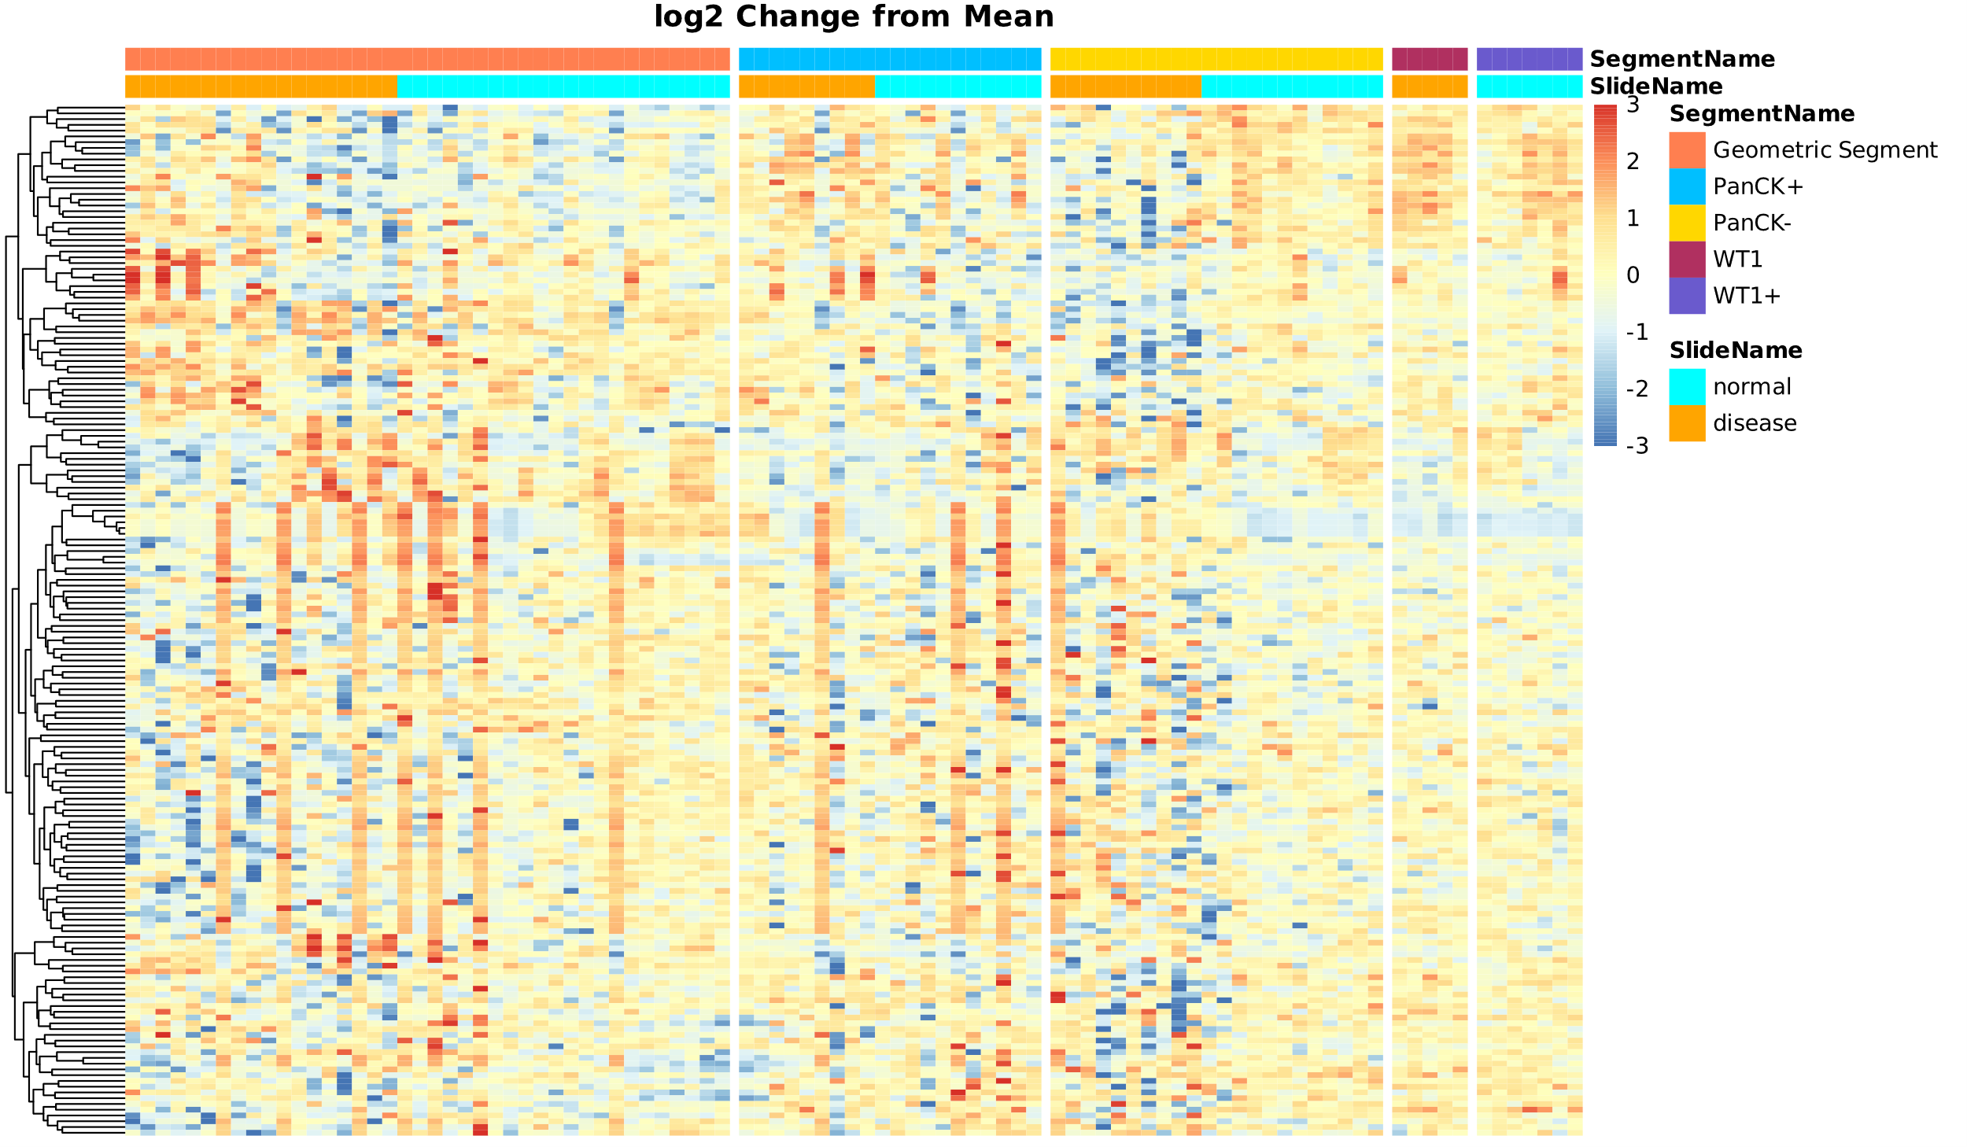**Example 1:**

sort_by <- “SegmentName”

annotation_colors <- list(

SlideName = c(

"normal" = "cyan",

"disease" = "orange"),

SegmentName = c(

"Geometric Segment" = "coral",

"PanCK+" = "deepskyblue",

"PanCK-" = "gold1",

"WT1” = "maroon",

"WT1+” = "slateblue"))

**Example 2:**

scale_cutoff <- 1

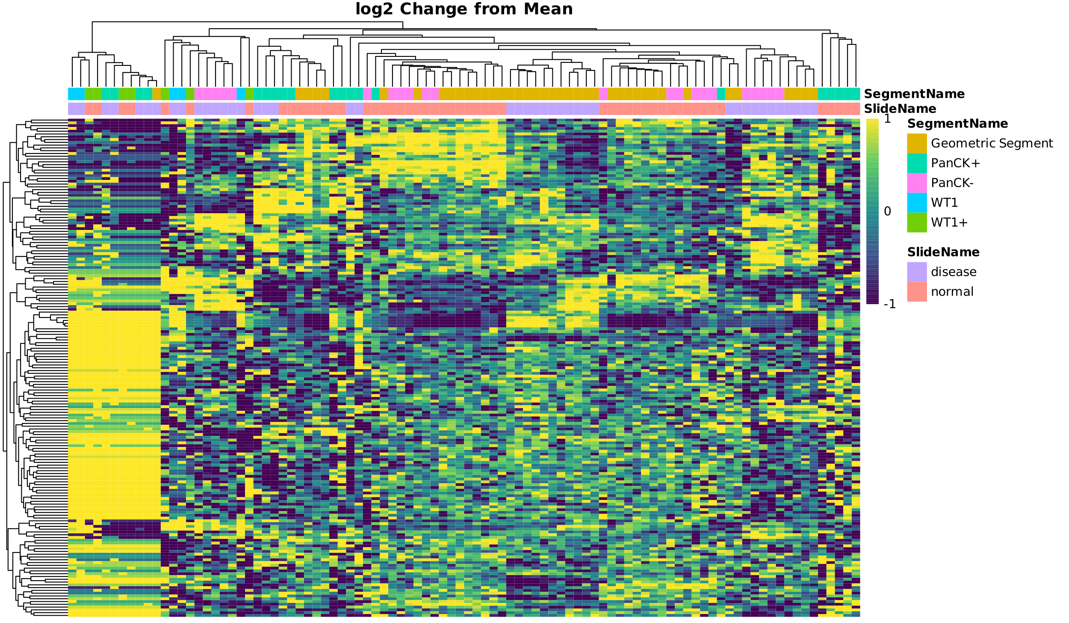heatmap_colors <- viridis::viridis(5)